Prayer of Illumination
Holy God, our hope and strength, by the power of your Spirit prepare the way in our hearts’ for the coming of your Word, so that we may see the glorious signs of your promise fulfilled; through Jesus Christ our Lord. Amen.
Scripture Lessons: Isaiah 7:10-16, Romans 1:1-7, Matthew 1:18-25
The Word of God for the people of God.

Thanks be to God.
Singing Our Faith #229 “Infant Holy, Infant Lowly”
The Good News “Surprising Signs”

Bringing Forward God’s Tithes and Our Gifts
*Doxology # 95 Praise God from whom all blessings flow; praise him, all Creatures here below; praise him above, ye heavenly host; praise Father, Son, and Holy Ghost. Amen.
*Prayer of Thanksgiving
Sharing of Joys and Concerns
The Lord’s Prayer

Our Father, who art in heaven, hallowed be thy name. Thy kingdom come, Thy will be done on earth as it is in heaven. Give us this day our daily bread and forgive us our trespasses, as we forgive those who trespass against us. And lead us not into temptation, but deliver us from evil. For thine is the kingdom, and the power, and the glory, forever. Amen.
*Singing Our Faith #224 “Good Christian Friends, Rejoice”
*Blessing and Dismissal
*Postlude

Scatter to Serve God & Neighbor

Chestnut Hill United Methodist Church

10:30 a.m. ~ December 21, 2025 ~ Fourth Sunday of Advent
Our ministry vision for the Virginia Annual Conference is “to be
disciples of Jesus Christ who are lifelong learners, who influence others to serve.”

Welcome! Join us in worshiping God!
Prelude
Welcome and Ministry Announcements
Welcome in the name of Christ our Lord. Please register your attendance, printing your name, address, phone, and email, on the attendance pad provided on your pew. Thank you for silencing cell phones as we gather to worship God.
Invocation
*Greeting
The king of glory comes
The nation rejoices
Open the gates before Him
Lift up your voices
Who is the king of glory?
How shall we call Him?
He is Emmanuel
The promised of ages
In all of Galilee
In city or village
He goes among His people
Curing their illness
Lift up your voices
Sing then of David's son
Our Savior and brother
In all of Galilee
Was never another

He gave His life for us
The pledge of salvation
He took upon Himself
The sins of the nation
He conquered sin and death
He truly has risen
And He will share with us
His heavenly vision
The king of glory comes
The nation rejoices
Open the gates before Him
Lift up your voices
*Singing Our Faith #237 (vs. 1 & 2) “Sing We Now of Christmas”
Lighting of the Advent Wreath Ron & Jane Hood
“For a child has been born for us, a son given to us; authority rests upon his shoulders; and he is named Wonderful Counselor, Mighty God, Everlasting Father, Prince of Peace. His authority shall grow continually, and there shall be endless peace for the throne of David and his kingdom. He will establish and uphold it with justice and with righteousness from this time onward and forevermore. The zeal of the Lord of hosts will do this.” (Isaiah 9:6-7)
We light this candle as a symbol of the Prince of Peace. May the visitation of your Holy Spirit, O God, make us ready for the coming of Jesus, our hope and joy. O come, O come, Emmanuel.

Opening Prayer
Purify our conscience, Almighty God, by your daily visitation, that your Son Jesus Christ, at his coming, may find in us a mansion prepared for himself; who lives and reigns with you, in the unity of the Holy Spirit, one God, now and for ever. Amen.

Anthem “Love Has Come”

Greeting Friends and Neighbors

Welcome to all! We gather to praise God for the innumerable blessings given to us and to grow deeper in the Spirit. Joyfully, let us lift our hearts to God.
**Calendar **

Christmas Holiday ~ Church Office Closed
Wednesday, December 24th thru Friday December 26th
Wednesday, 12/24 | 5:00 p.m. | Christmas Eve Candlelighting Service
**Looking Ahead on the Calendar **
Wednesday, 12/31 |  | Deadline for articles  (January/February/March)
2025 Christmas Offering
Our 2025 Christmas Offering will go towards the painting on the outside of the church. Goal-$6,000.00. Christmas offering envelopes are provided in the pew racks.

Birthdays Coming Up: (December) 22-Jane White, 23-Linda Jessen, Loretta Mayhew, 29-Cookie Fish

Estimate of Giving for 2026
It is that time of year when we are asked to take a prayerful look at our giving and to make a financial commitment for CHUMC ministries. Estimate of Giving cards are placed in the Commons (and the church office). Put it in the weekly offering plate, or mail in, so that we have your pledge by the end of December.

For the Grocery Cart:
December ~ Side dishes for a holiday meal; stuffing, cranberry sauce, instant potatoes, canned vegetables, etc. Place donations in the grocery cart, located in the Commons.

The Upper Room
The large edition of the Upper Room is now available. The small edition of the Upper Room is running late. As soon as they arrive we will inform you.
Mitten Tree Trunk
We are asking for mittens, gloves, warm hats, scarves, and new or gently-used warm jackets. These items will be delivered to Humankind sometime after Christmas. A deadline will be announced later.

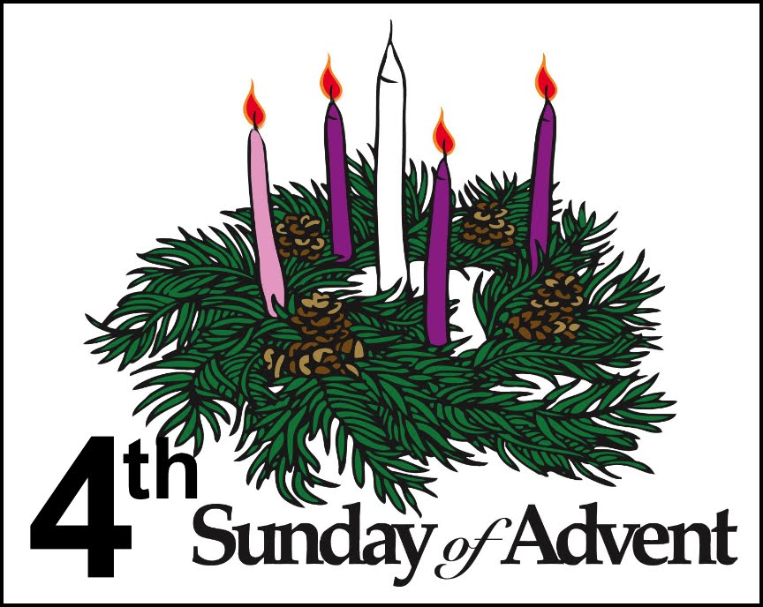

DIRECTORY OF CHESTNUT HILL UNITED METHODIST CHURCH
Adam J. White | Minister
Sharon Mayhew | Director of Music
Monica Campbell | Administrative Assistant
Judy Martin | Bookkeeper
Judy Robertson  Elizabeth Nichols | Lay Leader  Missionary in Henry County

Welcome to all! We gather to praise God for the innumerable blessings given to us and to grow deeper in the Spirit. Joyfully, let us lift our hearts to God.
**Calendar **
Christmas Holiday ~ Church Office Closed
Wednesday, December 24th thru Friday December 26th
Wednesday, 12/24 | 5:00 p.m. | Christmas Eve Candlelighting Service
**Looking Ahead on the Calendar **
Wednesday, 12/31 |  | Deadline for articles  (January/February/March)
2025 Christmas Offering
Our 2025 Christmas Offering will go towards the painting on the outside of the church. Goal-$6,000.00. Christmas offering envelopes are provided in the pew racks.
Birthdays Coming Up: (December) 22-Jane White, 23-Linda Jessen, Loretta Mayhew, 29-Cookie Fish

Estimate of Giving for 2026
It is that time of year when we are asked to take a prayerful look at our giving and to make a financial commitment for CHUMC ministries. Estimate of Giving cards are placed in the Commons (and the church office). Put it in the weekly offering plate, or mail in, so that we have your pledge by the end of December.

For the Grocery Cart:
December ~ Side dishes for a holiday meal; stuffing, cranberry sauce, instant potatoes, canned vegetables, etc. Place donations in the grocery cart, located in the Commons.

The Upper Room
The large edition of the Upper Room is now available. The small edition of the Upper Room is running late. As soon as they arrive we will inform you.
Mitten Tree Trunk
We are asking for mittens, gloves, warm hats, scarves, and new or gently-used warm jackets. These items will be delivered to Humankind sometime after Christmas. A deadline will be announced later.

DIRECTORY OF CHESTNUT HILL UNITED METHODIST CHURCH
Adam J. White | Minister
Sharon Mayhew | Director of Music
Monica Campbell | Administrative Assistant
Judy Martin | Bookkeeper
Judy Robertson  Elizabeth Nichols | Lay Leader  Missionary in Henry County


C hestnut Hill
United Methodist Church

Making disciples of Jesus Christ
for the transformation of the world.
You are welcome at Chestnut Hill UMC.

4660 Fort Avenue ~ Lynchburg, Virginia 24502
Church: 434-239-8423
Minister’s Cell: 434-944-7723, Minister’s Email: awhite@ves.org
Email: chestnuthillumc@comcast.net
On the Web at chestnuthillumc.net
Find us on Facebook: Chestnut Hill United Methodist Church

